 **Introduction to DevOps**

**BCS/BS 6A**

Lab: 07

# GROUP MEMBERS:

MUHAMMAD SHAYAN SHAHID (2212325)

MUHAMMAD ASHAD BAIG (2212115)

Task 1: View and assign roles

In this task, we will assign the Virtual machine contributor role.

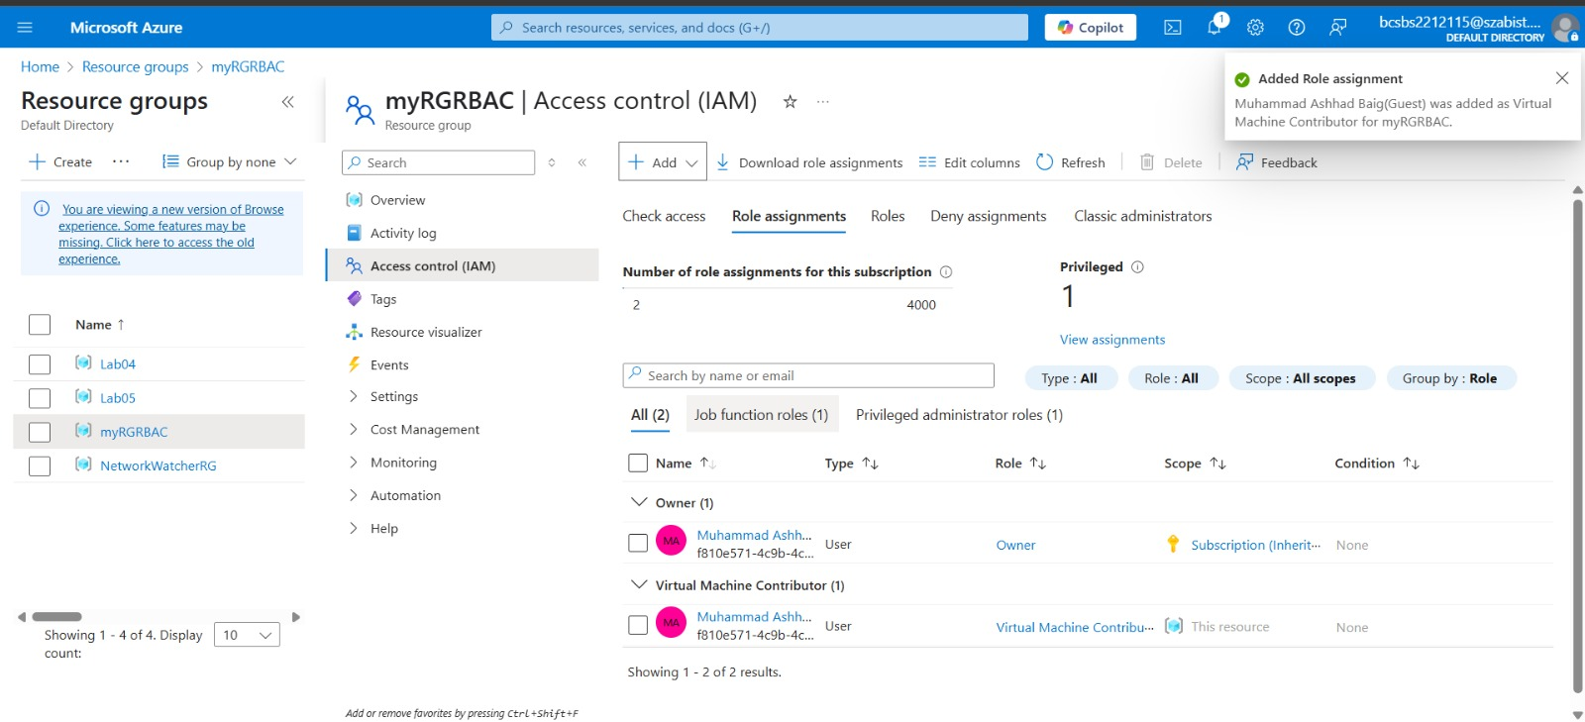

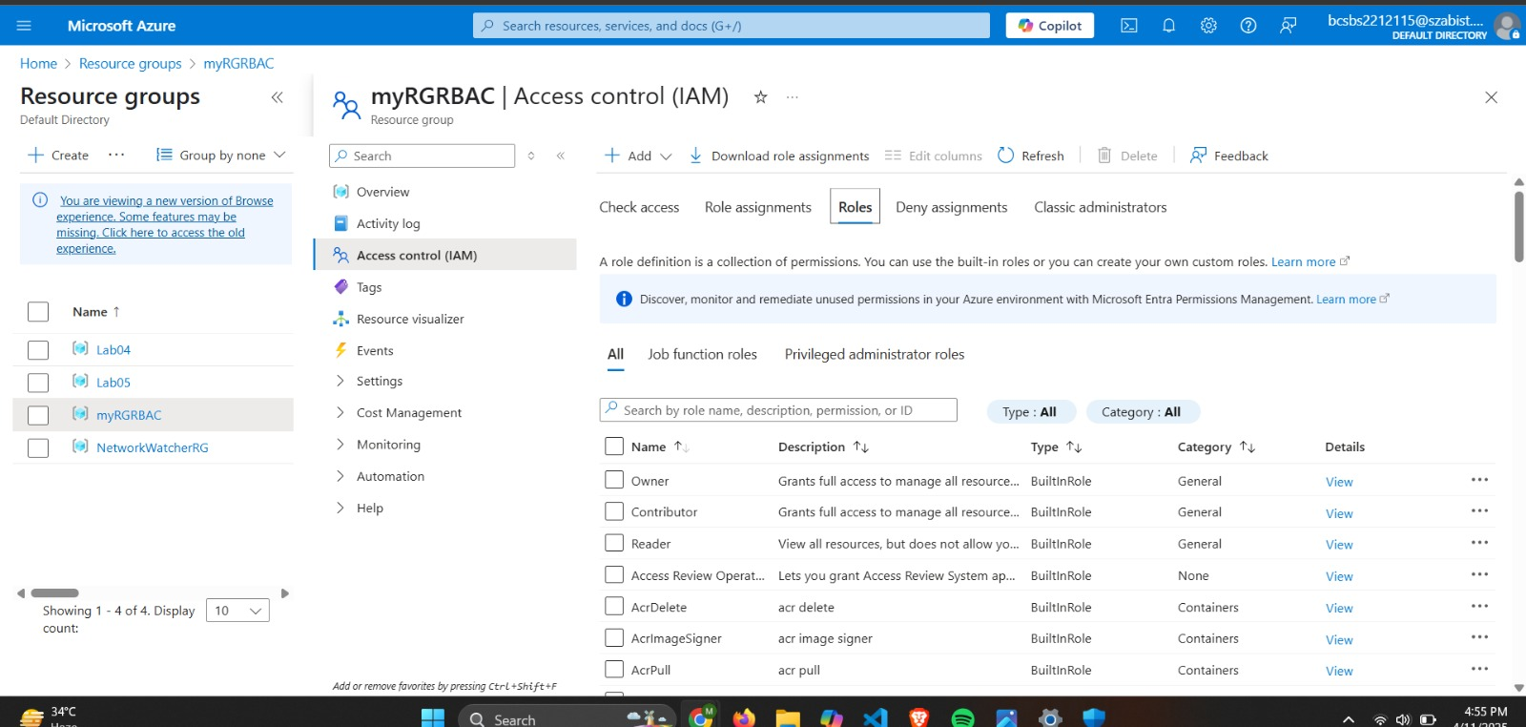

Task 2: Monitor role assignments and remove a role

In this task, we will view the activity log to verify the role assignment, and then remove the role.

